Introduction :
- It is a framework for packet mangling .
- Each protocol defines “hooks” which are well-defined points in a packet’s traversal of that protocol stack.
- At each of these points , the protocol will call the netfilter framework with the packet and the hook number .
- Kernel can register to these hooks and manage packets .
- ip_tables provide the rules_set which does the packet mangling .

Program :

import iptc
table = iptc.Table(iptc.Table.FILTER)
chain = iptc.Chain(table,'FORWARD')
#policy = iptc.Policy(iptc.Policy.ACCEPT)
rule = iptc.Rule()
#rule.in_interface = "wlo1"
rule.src="98.136.103.24/255.255.255.0"
rule.dst="98.136.103.24/255.255.255.0"
rule.protocol="tcp"
match=iptc.Match(rule,"state")
match.state="RELATED,ESTABLISHED"
rule.add_match(match)
rule.target=iptc.Target(rule,"DROP")
chain.insert_rule(rule)
table.commit()
#displays all the chains in that particular table
for chain in table.chains:
print(chain.name)
for rule in chain.rules:
print(rule.protocol,rule.src,rule.dst)
for match in rule.matches:
print(match.name)
print(rule.target.name)
#chain.delete_rule(rule)

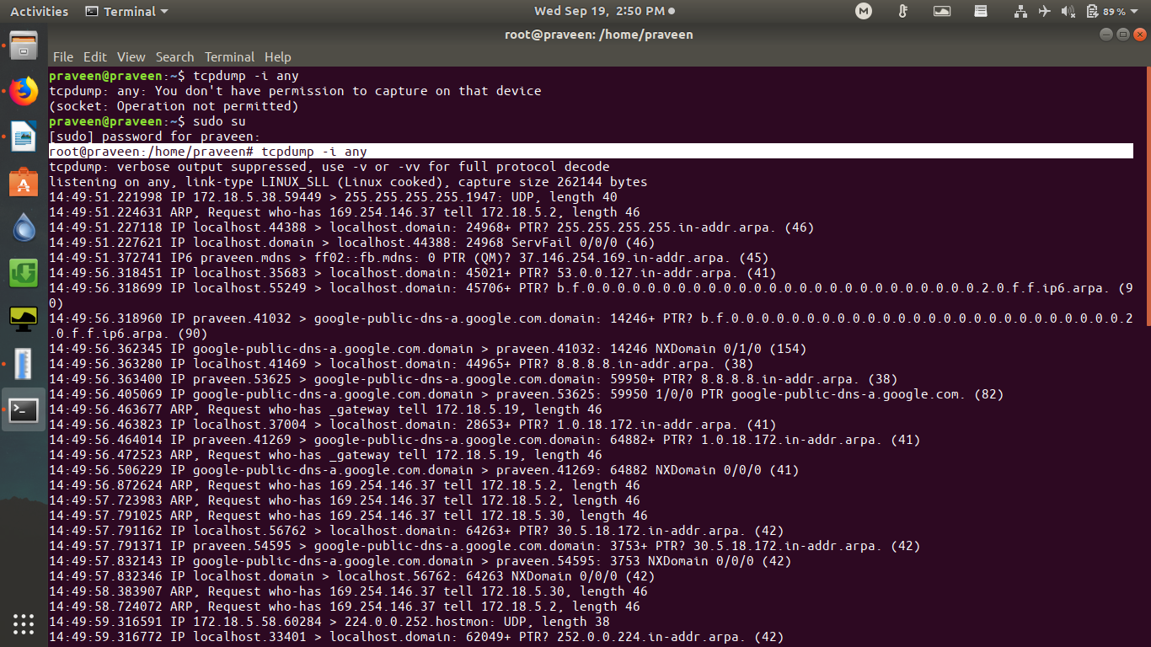

OUTPUT :

before adding rules
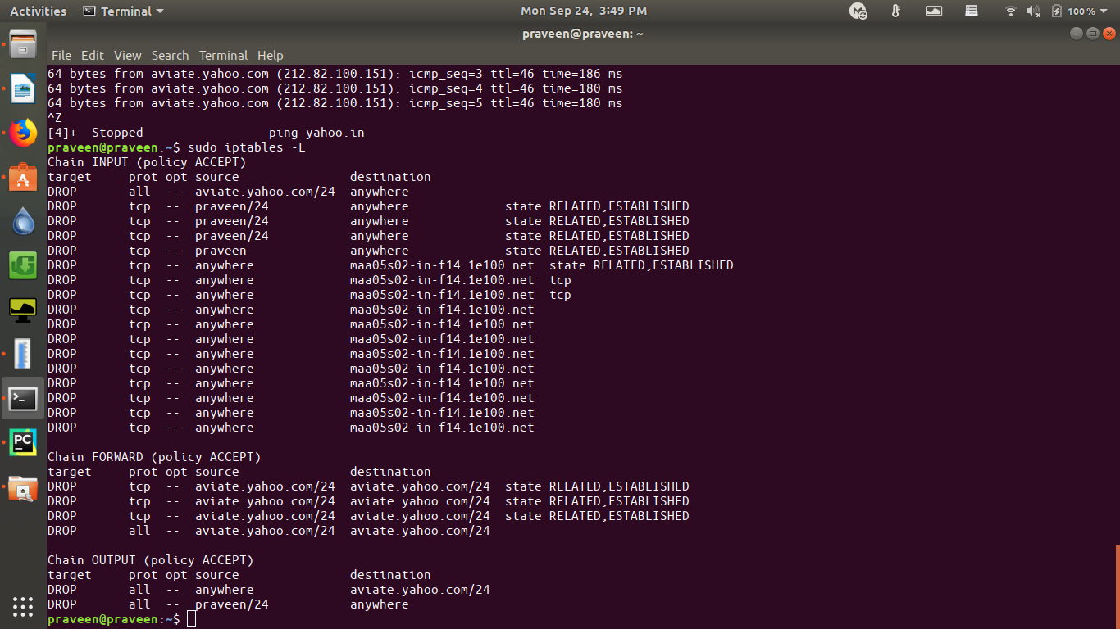

after adding rules

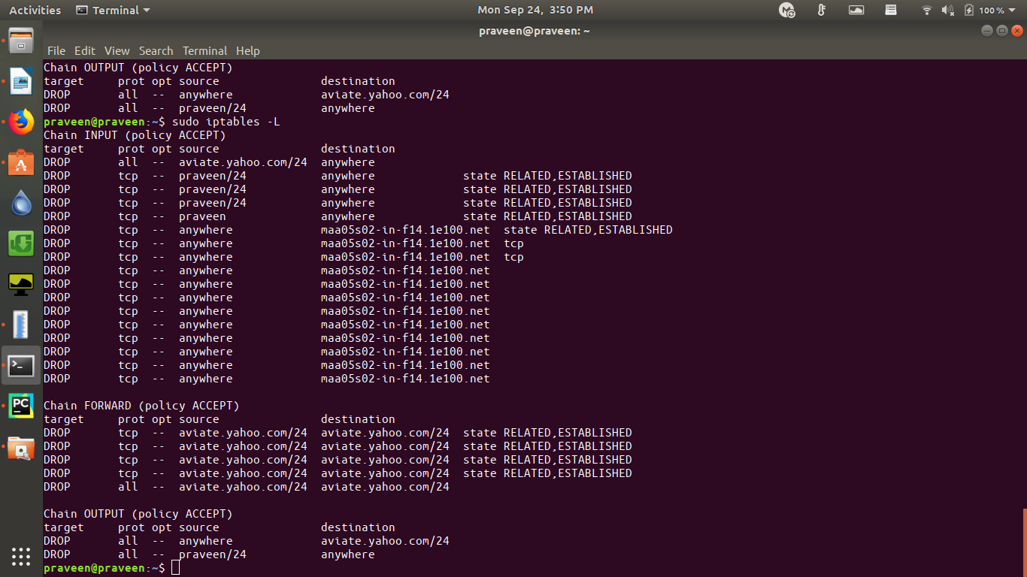

python-iptables :

Iptables is the tool that is used to manage netfilter, the standard packet filtering and manipulation framework under Linux.

- Iptables is used to set up, maintain, and inspect the tables of IPv4 packet filter rules in the Linux kernel. Several different tables may be defined.
- Each table contains a number of built-in chains and may also contain user- defined chains.
- Each chain is a list of rules which can match a set of packets. Each rule specifies what to do with a packet that matches. This is called a target, which may be a jump to a user-defined chain in the same table.

Installating via pip :

>pip install --upgrade python-iptables

main classes in python-iptables :

1) Table :

A table is the most basic building block in iptables.

Different tables :

- Table.FILTER – filter table
- Table.NAT – NAT table
- Table.MANGLE – MANGLE table
- Table.RAW – RAW table

to get access to table :

table = iptc.Table(iptc.Table.FILTER)

options :

a)table.ALL – lists all the tables

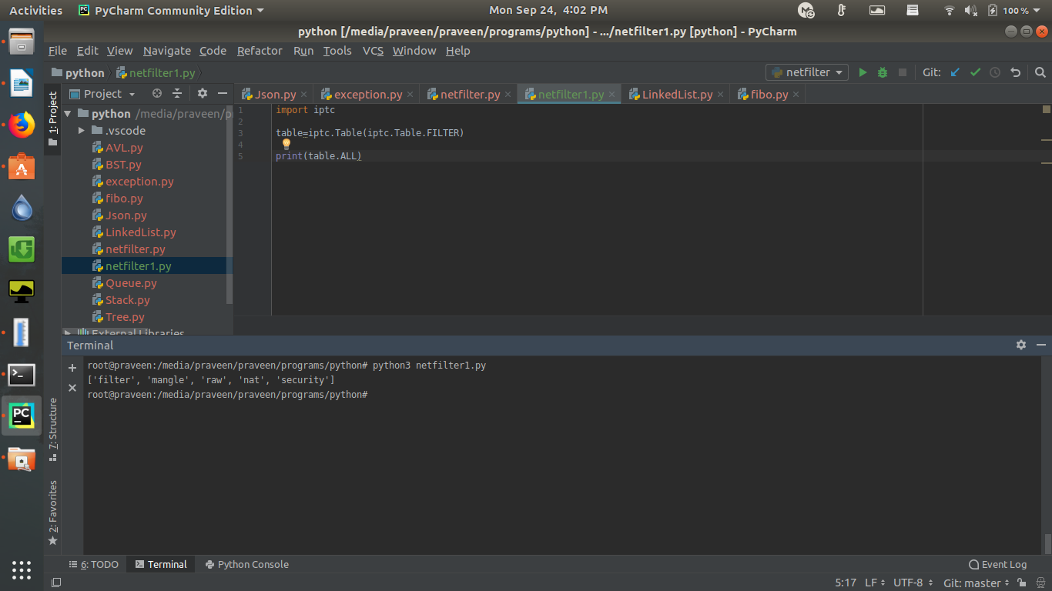

b)list all chains in the table

program :

import iptc
table=iptc.Table(iptc.Table.FILTER)
#print(table.ALL)
for chain in table.chains:
print(chain.name)

output :

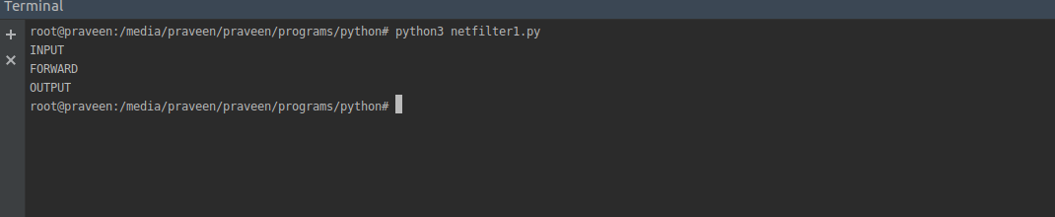

2)Chain :

chain contains the rules .

a) insert_rule – insert the rule as first entry in the chain eg : first program

b)flush – flush all rules from chain

program :

import iptc
table=iptc.Table(iptc.Table.FILTER)
for chain in table.chains:
chain.flush()
output :
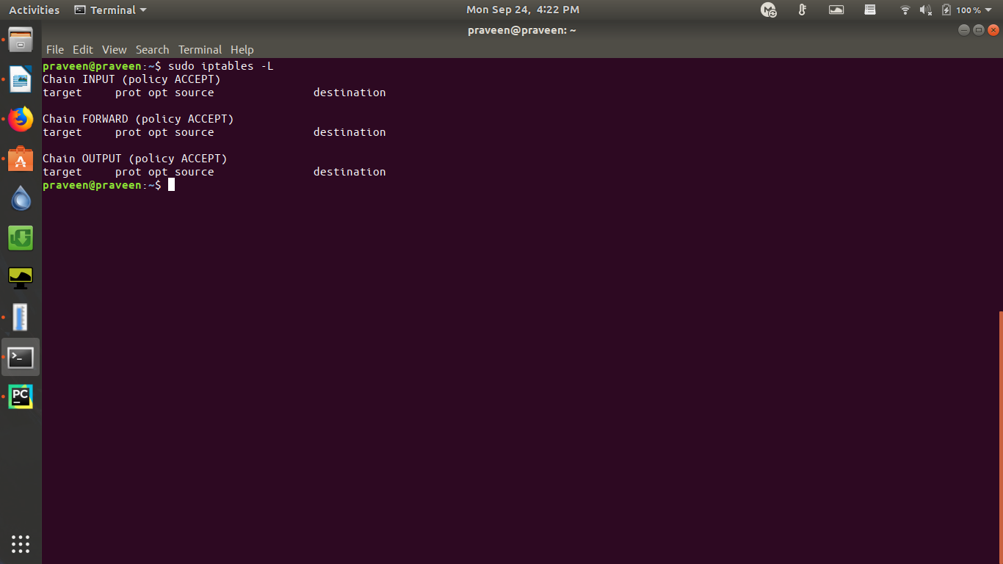

3 ) Target :
Targets specify what to do when rule is matched for a packet . It can drop the packet or accept the packet .

References :
- https://python-iptables.readthedocs.io/en/latest/
- https://netfilter.org/documentation/HOWTO//netfilter-hacking-HOWTO.html

